The European Programme for
Human Rights Education for Legal Professionals (HELP)
with support from
the United Nations High Commisioner for Refugees (UNHCR)
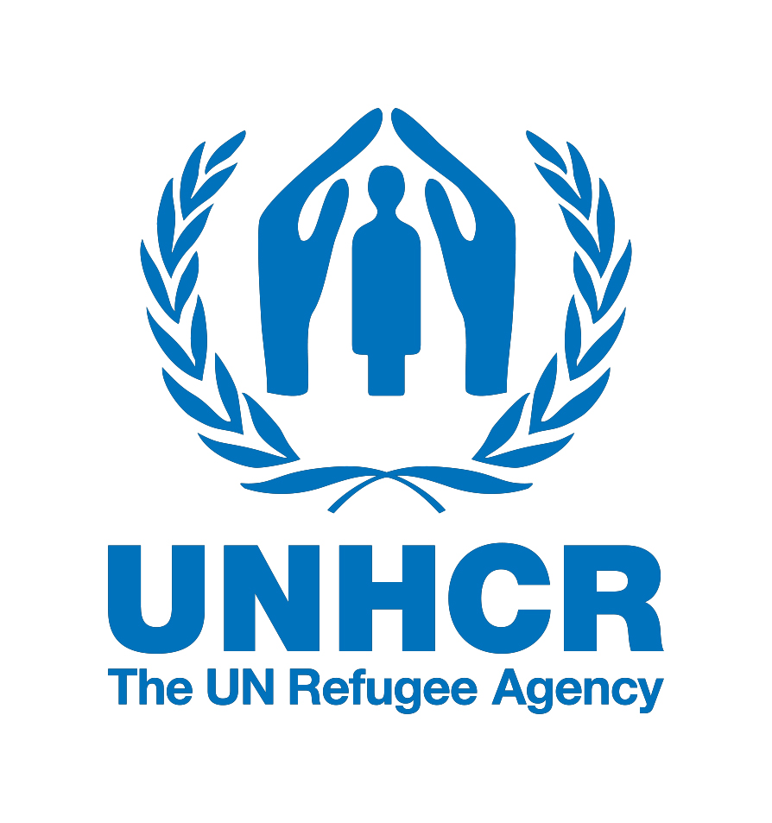

HELP Kick-off Meeting on Refugee and Migrant Children
Athens, 10th December 2018
Athens Bar Association
60 Akadimias Street, 106 79

AGENDA

Background

The Council of Europe (CoE) Programme for Human Rights Education for Legal Professionals (HELP) is aimed at supporting the CoE member States in implementing the European human rights standards at the national level, focusing on the European Convention on Human Rights (ECHR), other key CoE instruments and, since 2015, EU law. This is done by raising the capacities of legal professionals to apply those instruments in their daily work.
The objective of HELP is to provide high quality education on human rights to judges, lawyers and prosecutors throughout Europe. Thanks to HELP courses, legal professionals can better protect human rights on a national level and keep up to date with the ever-evolving standards and case law of the European Court of Human Rights (ECtHR). HELP courses specifically designed for EU countries increasingly incorporate relevant EU laws.

HELP is:
- the only pan-European Network of national training institutions for judges, prosecutors and lawyers in the 47 CoE Member States.
- an e-learning platform with free on-line courses on human rights.
- a human rights training methodology for legal professionals.

Refugee and Migrant Children
The mass arrivals of those seeking refuge in Europe from war and persecution, as well as the continuing movement of persons across the Mediterranean and Turkey, act as a constant reminder of the precarious situation refugees and migrants find themselves in. All Council of Europe member states are affected by the refugee/migration flows, either directly or indirectly, as countries of origin, transit, destination or resettlement.

Children on the move, especially in an irregular way, remain one of the most vulnerable groups in Europe today. For instance, some 26 000 child migrants arrived in Europe in 2015 without any accompanying family. Regardless of their status and the fact that they are accompanied or not, children on the move may suffer persistent violations of their rights.

To prevent further such violations, the European Programme for Human Rights Education for Legal Professionals (HELP), jointly with the Office of the Special Representative of the Council of Europe Secretary General on Migration and Refugees, Tomáš Boček, developed the HELP course on Refugee and Migrant Children. The course is one of the measures implementing the Council of Europe Action Plan on protecting Refugee and Migrant Children in Europe (2017-2019).

This course explains how critical issues are addressed in the international and European legal framework and provides an overview of the relevant case-law of the European Court of Human Rights. It allows legal and other professionals to improve their knowledge and skills on the existing standards in this area and to apply them in their daily work.

The National Course

During the launch, the participants will be registered on their respective course pages, prepared in advance by their national tutor. Over the following 2 to 3 months and based on the planning set by the tutor, the participants will go through the course, accessible in their respective national language and complemented by the national adaptation prepared by the tutors. The participants who have successfully completed the course and passed the evaluation set by the tutors will receive certificates issued by the HELP Programme of the Council of Europe in cooperation with the National Training Institutions.

Preparation

Before the launch, participants should:

- Watch the (5 minute) video on the HELP methodology: https://www.coe.int/en/web/help/home
- Create an account on the HELP e-learning platform

Further information

For additional information, please do not hesitate to contact Douglas Maxwell (douglas.maxwell@coe.int) at the HELP Secretariat.

10th December 2018
Athens Bar Association, 60 Akadimias Street, 106 79, 3rd Floor
09:00 – 09:30 | Arrival and registration of participants
Moderator
Thomas KAMENOPOULOS
Special Advisor of the President of the Athens Bar Association, former Vice President of the Athens Bar Association
09:30 – 09:45 | Welcoming address  Dimitrios VERVESOS  President of the Athens Bar Association
09:45 – 10:15 | Thematic Presentation from the UNHCR  Theodora TSOVILI  Senior Protection Assistant, UNHCR Greece
10:15 – 10:45 | Introduction to the HELP Programme  Ana-Maria TELBIS  Senior Project Coordinator, HELP Programme, Council of Europe
10:45 – 11:15 | Round table with the participants
11:15 – 11:45 | Coffee Break
11:45 – 13:20 | The Council of Europe Action Plan on Refugee and Migrants Children  Douglas MAXWELL  Project Officer, HELP Programme, Council of Europe  Refugee and Migrant Children: case law of the European Court of Human Rights and current challenges for Greece  Maria Andriani KOSTOPOULOU  Member of the HELP Consultative Board, Chair of the Ad Hoc Committee of the Council of Europe for the Rights of the Child
13:20 – 13:30 | Group Photo
13:30 – 15:00 | Lunch break
15:00 – 16:45 | Presentation of the online course and practical information for the participants  Danai ANGELI  Course Tutor, Lecturer at Bilkent University
16:45 – 17:15 | Conclusions: Questions & Discussion

For more information on HELP please see the last page of this document and visit HELP’s website: www.coe.int/help

