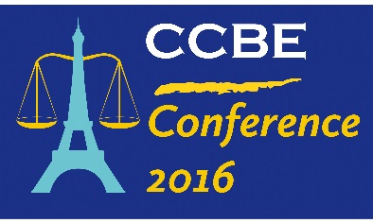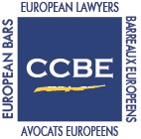

CCBE Meetings
Paris, 19-21 October 2016

Program

Wednesday 19 October 2016

- 10.00 – 18.00: Committee Meetings
Lunch offered by the Conseil National des Barreaux
Address: Conseil National des Barreaux, 22 Rue de Londres, 75009 Paris, France
- 14.00 – 18.00: Seminar on the European Court of Human Rights
Lunch offered by the Conseil National des Barreaux
Address: Conseil National des Barreaux, 22 Rue de Londres, 75009 Paris, France
- 19.00 – 23.00: Reception upon the kind invitation of the Conseil National des Barreaux (CNB) (venue TBC)
Thursday 20 October 2016

- 9.00 – 16.00: Standing Committee
Lunch offered by the Conseil National des Barreaux
Address: UIC-P Espaces Congrès, 16 rue Jean Rey - 75015 Paris
- 19.00 – 23.00: Dinner upon the kind invitation of the Paris Bar
Address: Maison du Barreau, Rue de Harlay, 75001 Paris, France
Friday 21 October 2016

- 8.30 – 17.00: CCBE Conference 2016 "Innovation and Future of the Legal Profession"
Lunch sponsored by the Conférence des Bâtonniers
Address: Eurosites George V, 28 Avenue George V, 75008 Paris
- 19.00: Dinner hosted by the Société de courtage des barreaux
Address : Restaurant Le Train Bleu, 1st floor, Gare de Lyon, Place Louis Armand, 75012 Paris

Hotels

To book your hotel and enjoy special CCBE rates, please use the attached forms.
- Mercure Paris Opéra Louvre, 95, rue de Richelieu, 75002 PARIS
- Novotel Paris Tour Eiffel, 61 Quai de Grenelle, 75015 PARIS
- Mercure Paris Opéra Faubourg Montmartre, 5 Rue de Montyon, 75009 PARIS

Map

To locate better all the venues, please click on this link.

