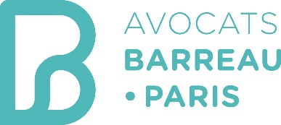
STAGE INTERNATIONAL

PROGRAM: « STAGE INTERNATIONAL »
Since 1991, the Paris Bar organises a unique training program targeting young French speaking lawyers, in partnership with the Ecole de Formation professionnelle des Barreaux du ressort de la cour d'appel de Paris (EFB). The "Stage International" brings together in Paris, during two months of theoretical and practical training, young French speaking lawyers, selected by the Paris Bar from among applications received each year from all over the world. This program is organised in cooperation with the foreign bar associations and supported by some French Embassies abroad.

WHEN ?
The Stage international takes place every year in October and November (8 weeks).

WHY?
The « Stage International » is first and foremost an encounter between lawyers in an international and fraternal atmosphere; they are an opportunity to compare practices and establish lasting bonds of friendship and business.
Objectives:
- Strengthen relations between the bars who can recommend participants;
- Create a network through the lawyers and firms who participated in the program;
- Promote the exchange of legal experience and knowledge as well as the practice of comparative law.

WHO?
This program is intended for French speaking young lawyers (up to 40 years) of any nationality willing to discover the practice of French law through quality education and a discovery of professional practice in Parisian volunteers law firms. These lawyers must have civil liability insurance; have a good knowledge of French.

WHAT?
Introduction to the French legal system: during the first month, the participants benefit from a training at the “Ecole de Formation du Barreau” to enable them to apprehend in a practical way the French legal system and its procedures in civil, criminal and commercial matters. They discover the daily reality of the Palais de Justice by going regularly to hearings, visit the major French institutions and discover the European Law.
Immersion in the life of a Parisian law firm: during the second month, they have the opportunity to be at the heart of the Parisian legal life alongside Parisian volunteers’ lawyers.

APPLICATION FORM:
Applications should include in particular the following documents: a curriculum vitae in French, a motivation letter in French, a photograph, a copy of the passport and a certificate of registration at the bar of the current year.

Registration until April 12, 2024 via the dedicated website.

WEB PAGE AND REGISTRATION SITE : https://www.avocatparis.org/stage-international

CONTACT: stageinternational@avocatparis.org

